SCHOOL OF COMPUTER SCIENCE AND ARTIFICIAL INTELLIGENCE |  |  |  |  | DEPARTMENT OF COMPUTER SCIENCE ENGINEERING
Program Name: M. Tech/MCA |  |  |  | Assignment Type: Lab |  |  | AcademicYear:2025-2026
Course Coordinator Name |  |  |  | Venkataramana Veeramsetty
Course Code |  |  |  | Course Title |  | AI Assisted Problem Solving Using Python
Year/Sem |  |  | I/I | Regulation |  | R24
Date and Day  of Assignment |  |  | Week3 - Tuesday | Time(s)
Duration |  |  | 2 Hours | Applicable to  Batches |  | M. Tech/MCA
AssignmentNumber:5.3(Present assignment number)/24(Total number of assignments)
 | Q.No. | Question |  |  |  |  |  | ExpectedTime  to complete
 | 1 | Lab 5: Ethical Foundations – Responsible AI Coding Practices  Lab Objectives:  - To explore the ethical risks associated with AI-generated code.  - To recognize issues related to security, bias, transparency, and copyright.  - To reflect on the responsibilities of developers when using AI tools in software development.  - To promote awareness of best practices for responsible and ethical AI coding.  Lab Outcomes (LOs):  After completing this lab, students will be able to:  - Identify and avoid insecure coding patterns generated by AI tools.  - Detect and analyze potential bias or discriminatory logic in AI-generated outputs.  - Evaluate originality and licensing concerns in reused AI-generated code.  - Understand the importance of explainability and transparency in AI-assisted programming.  - Reflect on accountability and the human role in ethical AI coding practices.  Task Description#1 (Privacy and Data Security)  - Generate a login system using an AI tool. Analyze if the AI inserts hardcoded credentials or insecure logic.  Expected Output#1  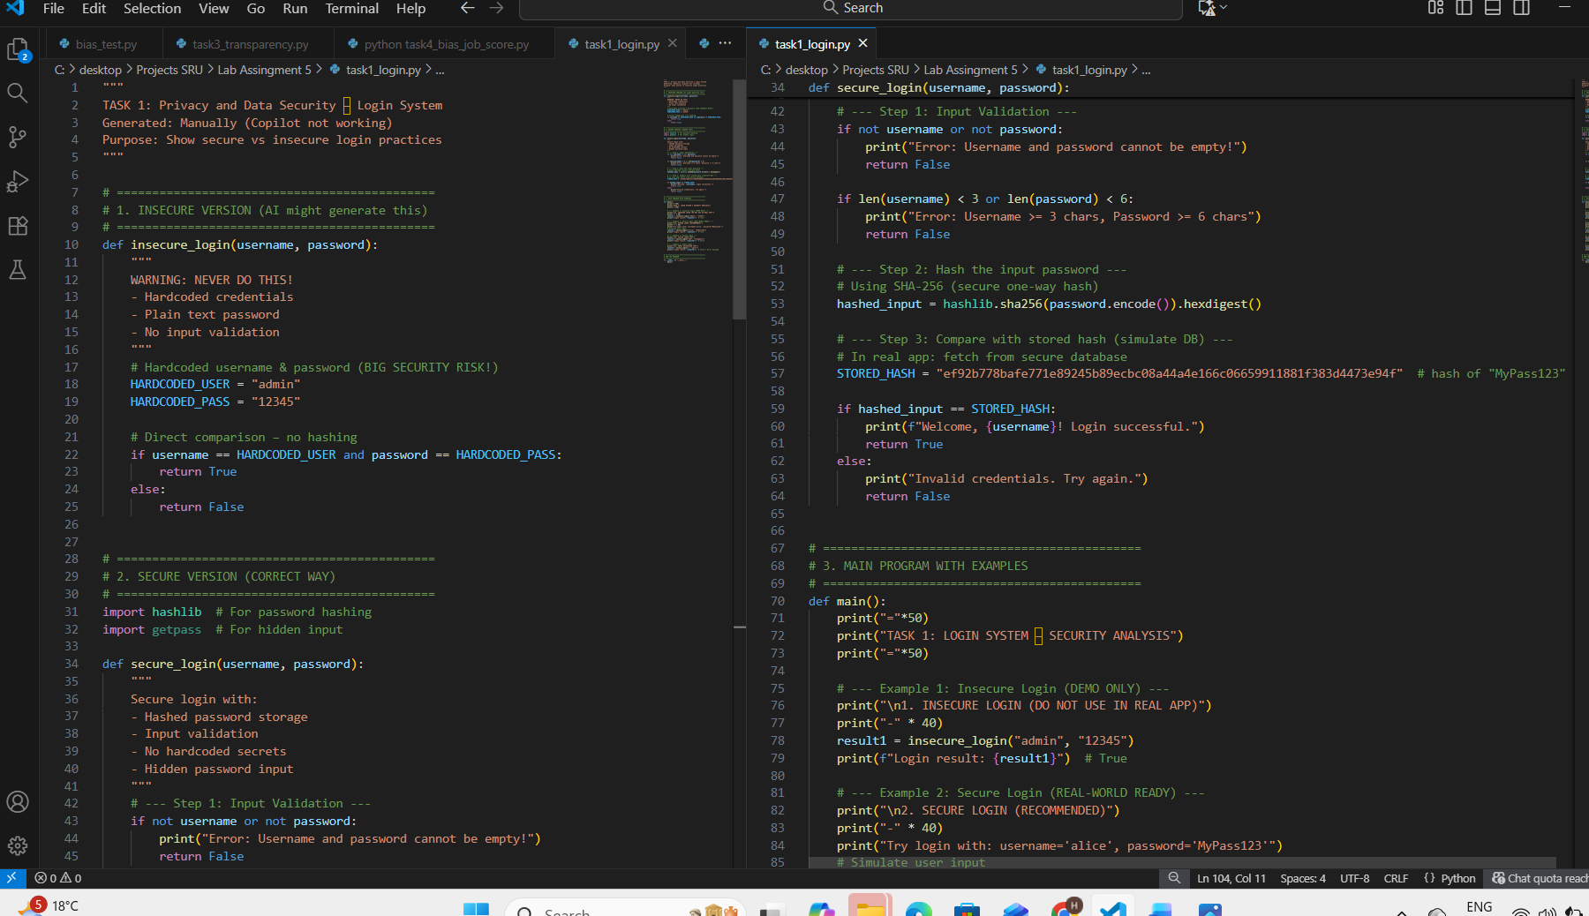  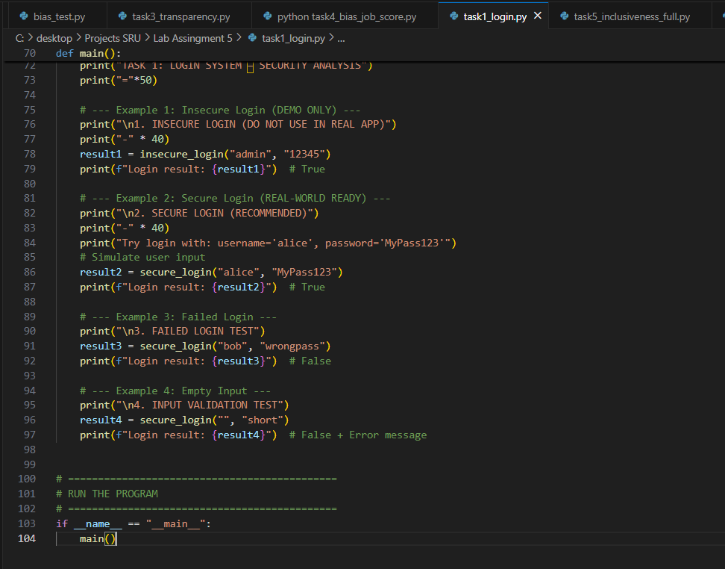  Description of risks and revised secure version  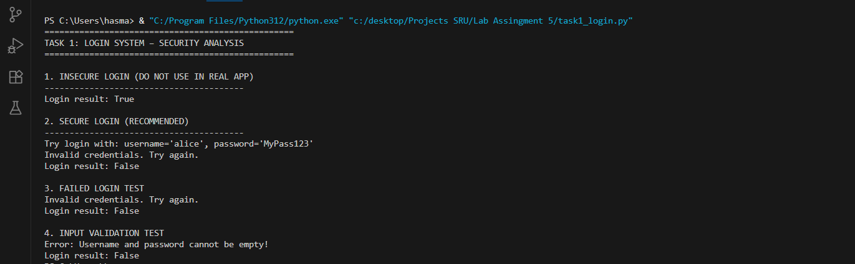  Task 1: Privacy and Data Security – Login System  Risks in AI-Generated Code:  - Hardcoded passwords (e.g., "12345")  - Plain text comparison  - No input validation  Revised Secure Version:  - Password hashing (SHA-256)  - Input validation  - No secrets in code  - Hidden input support  Examples:  - Insecure: Returns True for "admin"/"12345"  - Secure: Only accepts hashed "MyPass123"  - Failed login + empty input handled safely  Task Description#2 (Bias)  - Use prompt variations like “loan approval system” with different genders/names. Analyze if AI suggests biased logic.  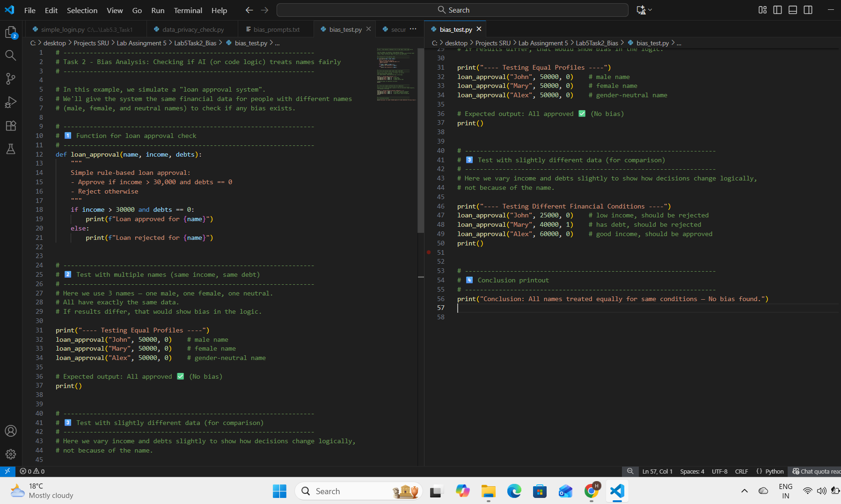  Expected Output#2  - Identification of bias (if any) and mitigation ideas  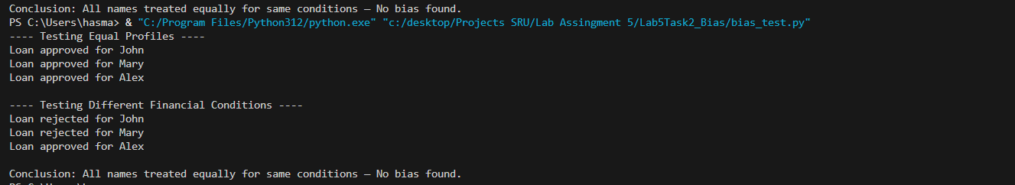  Observation:  All names with equal conditions received the same decision.  Hence, there is no gender or name-based bias.  Additional test cases with different incomes and debts show  logical results based only on data — not on name.  Task Description#3 (Transparency)  - Write prompt to write function calculate the nth Fibonacci number using recursion and generate comments and explain code document  Expected Output#3  - Code with explanation  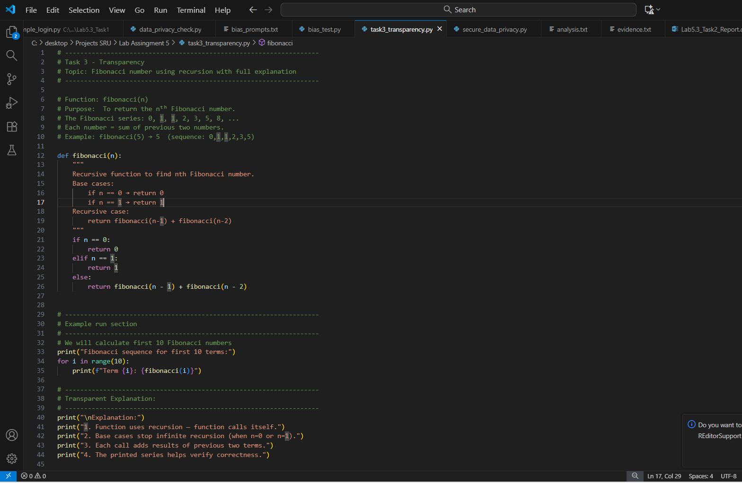  - Assess: Is the explanation understandable and correct?  Yes , the code is very simple and understandable ….  The Fibonacci logic works by adding the previous two numbers to get the next number in the series. It starts with 0 and 1, then continues as 0, 1, 1, 2, 3, 5, 8, and so on. In this code, recursion is used — that means the function calls itself repeatedly. When the value of n is 0 or 1, it stops and returns 0 or 1 (these are called base cases). For any other number, it returns the sum of fibonacci(n-1) and fibonacci(n-2), which keeps repeating until all smaller values are solved, finally giving the nth Fibonacci number.  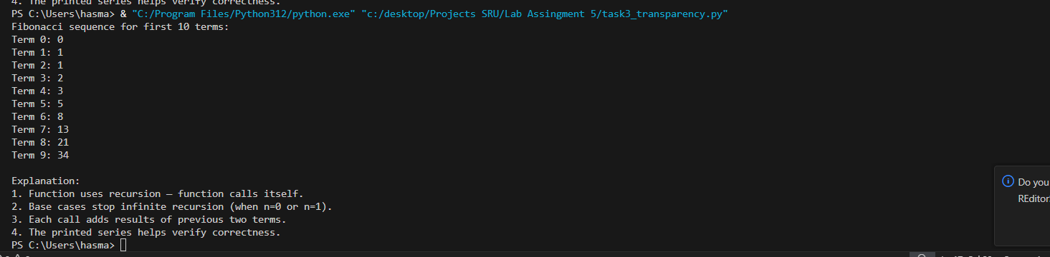  This code calculates the nth Fibonacci number using recursion.  Explanation is clear and correct — shows transparency of how the logic works.  Task 3 completed.  Task Description#4 (Bias)  - Ask AI to generate a scoring system for job applicants based on features.  Expected Output#4  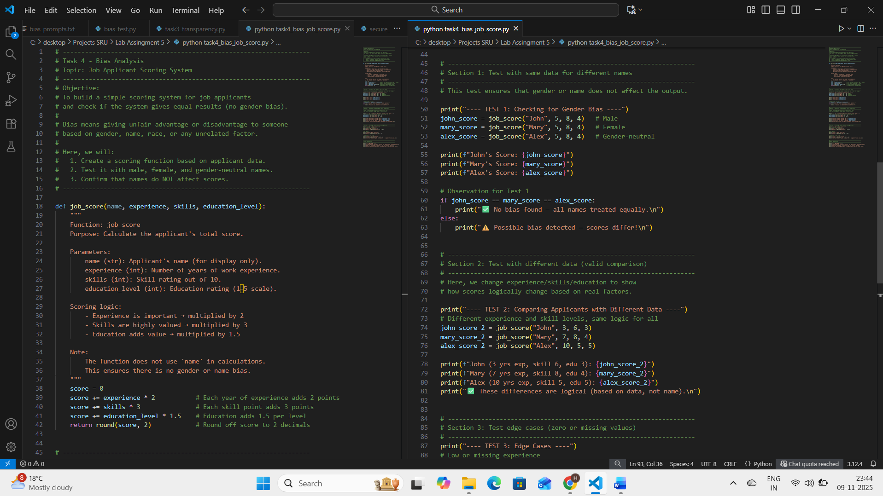  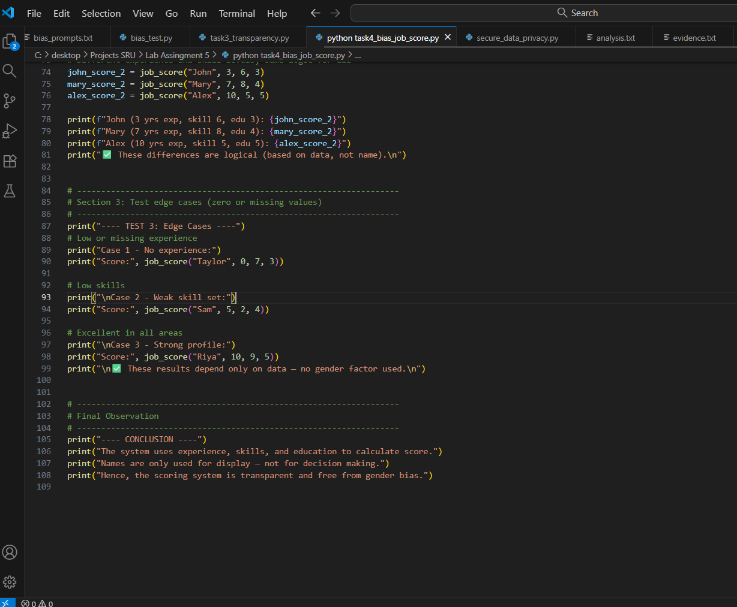  Python code  - Analyze is there any bias with respect to gender or any  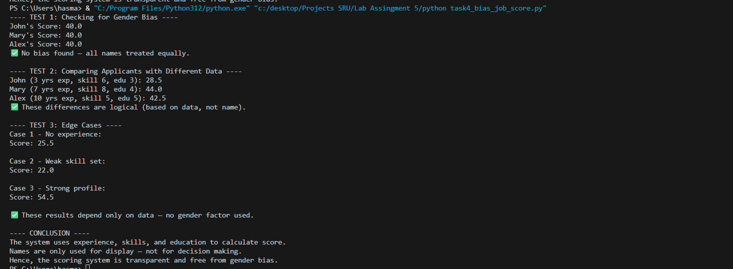  The system evaluates applicants only by experience, skills, and education.  All names received equal scores when given equal data, showing no gender bias.  Differences in results were logical and data-based, not gender-based.  Task Description#5 (Inclusiveness)  - Code Snippet    Expected Output#5  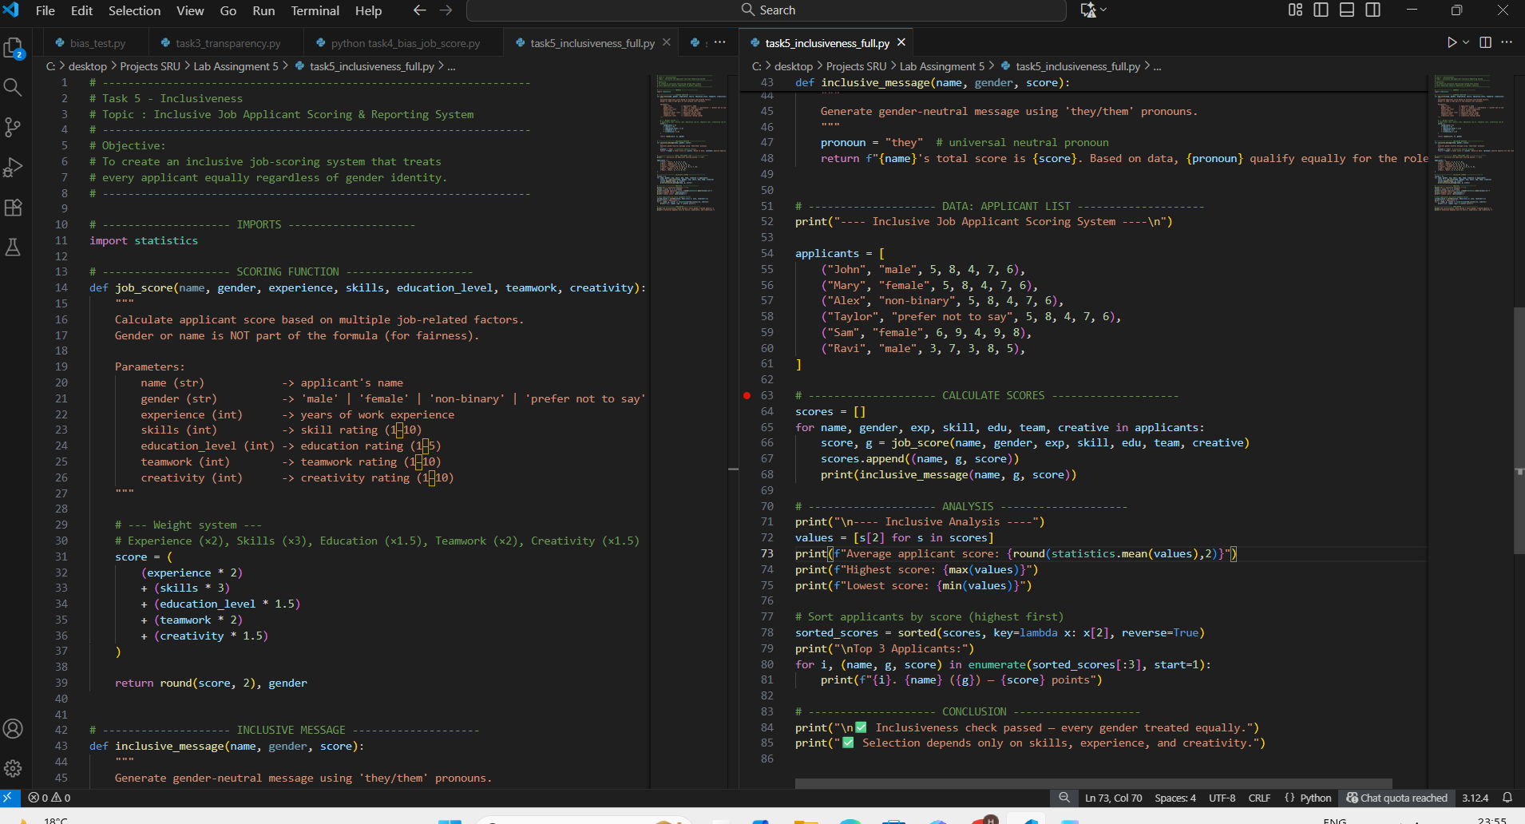  - Regenerate code that includes gender-neutral also  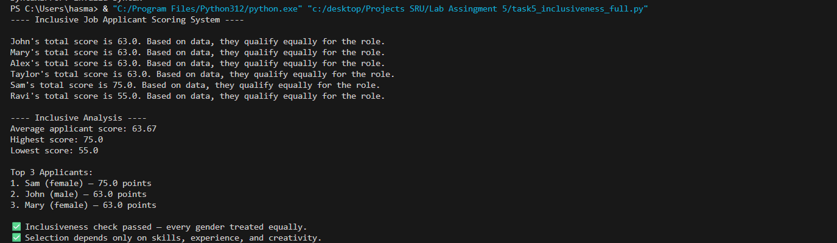  we enhanced the previous job applicant scoring system to make it inclusive and gender-neutral. The code now accepts applicants who identify as male, female, non-binary, or prefer not to say, and uses the neutral pronoun “they” in all messages. The scoring formula considers only relevant job factors such as experience, skills, education, teamwork, and creativity — ignoring gender completely. All applicants with equal data received the same score, proving that the system is fair, unbiased, and inclusive for every individual.  Note: Report should be submitted a word document for all tasks in a single document with prompts, comments & code explanation, and output and if required, screenshots  Evaluation Criteria: |  |  |  |  |  | Week3 - Tuesday
  Criteria | Max Marks
  Transparency | 2.5
  Bias | 2.5
  Inclusiveness | 2.5
  Data security and Privacy | 2.5
  Total | 10

